Returning Staff Application
Summer 2018

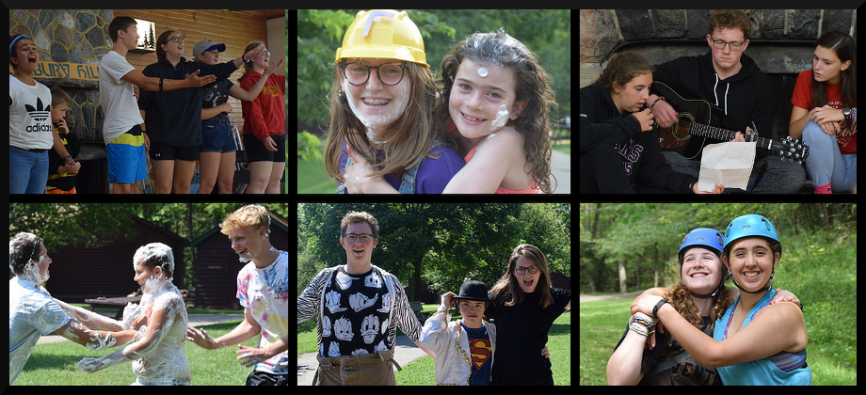

Last summer was very awesome, thanks to our 2017 staff team! Here’s a taste of what parents said:

“We are so fortunate to live in a place where so many opportunities and amazing experiences are available to our children. We have found all the summer camps the girls have been to really great but nothing compares to Canterbury Hills. The spirit, the enthusiasm, the variety of activities, the positive atmosphere, the environment is so exceptional.”

“We have been involved with Canterbury Hills camp for 3 years. This year in particular has had EXCEPTIONAL camp leaders. They are motivating, empathetic, positive, involved, caring, great communicators, who genuinely love their jobs. This year really stood out as having an incredible team of experienced leaders with a natural gift for working with kids. They had diverse personalities that came together to create the perfect team.”

A great camp experience is memorable for all the fun and good times, but the lasting impact comes from living in a safe and caring community with inspiring role models-- you, the staff! Campers discover who they are, what they are capable of, and what type of person they want to be. Camp experiences shape character, faith and destinies.

For summer 2018, we are building on the legacy of past summers by forming a passionate and energized staff. Together, we will care with excellence, create epic memories and bring our best to campers in cabins, forests, creeks, lunch tables, gaga ball courts, pools and fields.

We’ve redesigned the schedule so June training week doesn’t conflict with exams. We’re launching new Family and Alumni camps. We’re expanding Adventure Camp. We’re adding one Day and Overnight unit each session. Momentum is building. Summer is coming! If you’d like to be part of the 2018 staff team, READ ON!

FIRST NAME: LAST NAME:

ADDRESS: CITY/TOWN, PROVINCE:

POSTAL CODE: HOME PHONE:

CELL: EMAIL:

USERNAME FOR ONLINE INTERVIEWS (Skype, Facetime or Facebook):
CURRENT EDUCATION OR EMPLOYMENT:

CANTERBURY HILLS STAFF HISTORY (Please list year and role):

HIGHLIGHT IN BOLD THE SUMMER 2018 ROLES (BELOW) THAT YOU ARE APPLYING FOR:

- Overnight Cabin Leader (OCL)
- Day Camp Leader (DCL)
- Leader In Training (LIT) 2
- Adventure Camp (July 15-21, Aug. 29-25)
- Kitchen Staff (option to live on site with evening camp/program support or work days only)

QUALIFICATIONS & TRAINING
Please list any other certifications, skills, or training that you believe will be valuable as a member of the Canterbury Hills Camp Staff Team.

PLEASE ANSWER THE QUESTIONS BELOW:

- Why do you want to be on staff this summer?

- What did you do well last summer?

- What did you learn last summer?

- What would you do differently or better this summer?

- How can you help our staff work be stronger, better or more effective?

- When new energy or ideas can you bring to Canterbury Hills?

- What is your favourite treat that is purchased from a store?

SUMMER 2018 SCHEDULE:

- STAFF TRAINING WEEKEND: Fri. May 18 (evening) to Mon. May 21 (afternoon)

- ALUMNI CAMP: Sat. June 23-24 (optional for staff)

- STAFF TRAINING WEEK: Wed. June 27 (after breakfast) to Wed. July 4 (afternoon)

- FAMILY CAMP: Fri. July 6 (after dinner) to Sat. July 7 (after campfire)

- CAMP SESSIONS:

- July 8-13, O1 (5 nights / ages 7-14)
- July 9-13, D1 (5 days / ages 5-10)

- July 15-21, O2 (6 nights / ages 7-15)
- July 16-20, D2 (5 days / ages 5-10)
- July 15-21, ADV1 (6 nights / ages 13-15)

- July 22-27, O3 (5 nights / ages 7-14)
- July 23-27, D3 (5 days / ages 5-10)

- July 29 - Aug 3, O4 (5 nights / ages 7-14)
- July 30 - Aug. 3, D4 (5 days / ages 5-10)
- July 29 - Aug 4, LIT Adventure (6 nights / ages 15-16)

- Aug 6-10, O5 (4 nights / ages 7-14)
- Aug 7-10, D5 (4 days / ages 5-10)

- Aug 12-17, O6 (5 nights / ages 7-14)
- Aug 13-17, D6 (5 days / ages 5-10)

- Aug 19-24, O7 (5 nights / ages 7-15)
- Aug 20-24, D7 (5 days / ages 5-10)
- Aug. 19-25 ADV 2 (6 nights / ages 13-15)

- Camp Clean-up and Staff Eucharist: Aug. 25 (morning/afternoon)

RETURNING STAFF REFLECTION INTERVIEWS: Sat. Feb. 3 or 10, 2018

Please make YES or NO bold to indicate your interview date preferences:

I am available on both Feb. 3 and 10 ……. YES or NO

My preference is Feb. 3 …………………… YES or NO

My preference is Feb. 10 …………………. YES or NO

MARCH BREAKAWAY: Thurs. Mar. 15 and Fri. Mar. 16, 2018

I am interested in being on staff for March Breakaway …… YES or NO (bold your answer)

I am interested in being a 1:1 staff for March Breakaway …… YES or NO (bold your answer)

SUBMIT YOUR RETURNING STAFF APPLICATION BY FEB. 1 TO:
Lance Wright
director@canterburyhills.ca

Or, feel free to email or phone (905-648-2712 ext. 2) if you have any questions.

-----

Canterbury Hills Camp is affiliated with the Diocese of Niagara, Anglican Church of Canada
Mailing Address: c/o 252 James Street North, Hamilton, ON L8R 2L3
www.canterburyhillscamp.ca

